EE 97 Fall 2016

Thurs. 1330

Lab #2: Graph of Current vs. Voltage of a Two-Terminal Component

Sidarth Shahri

partner: Christian Lopez

Station 10

submitted 15 September 2016

**Lab #2: Graph of Current vs. Voltage of a Two-Terminal Component**

**Experiment #1**

The HP E3631A is capable of providing three independent DC voltages simultaneously. It can provide, +6V, +25V, and -25V. These can be further combined in various circuit set-ups to produce any range of voltages. Each of the voltage sources can be varied to provide any voltage up to the maximum stated voltage of +6V, +25V, and -25V, respectively. There are three outputs from the device. There are also accompanying ground 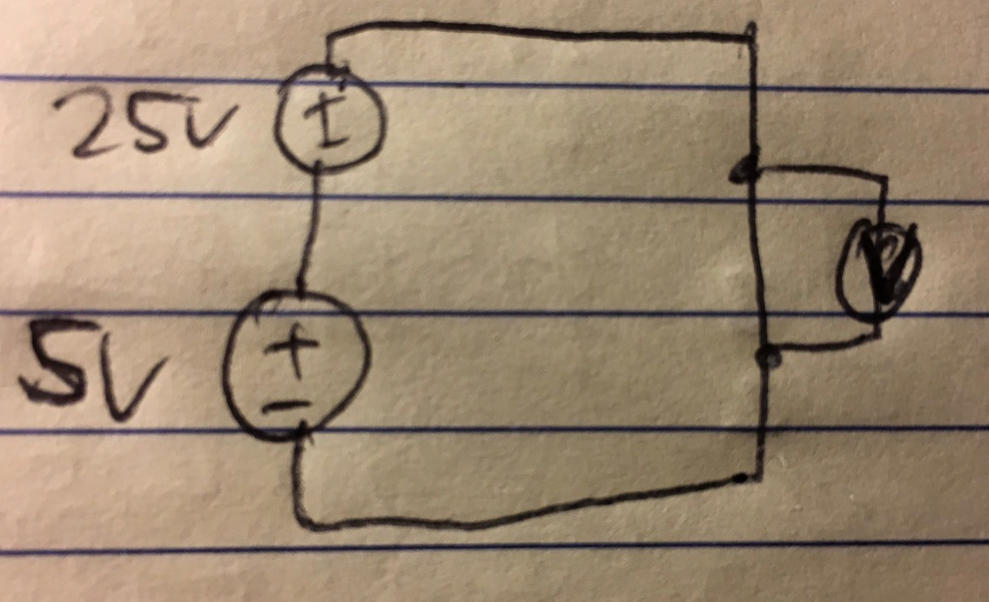inputs.

In this experiment, we combined the multiple outputs to create any voltage within the range of the device.

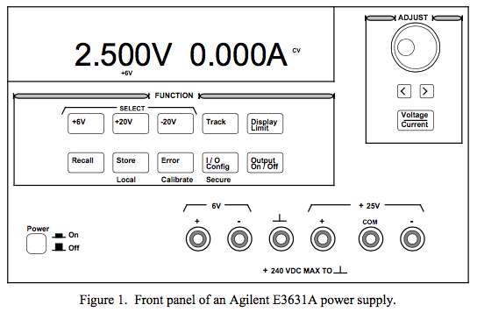

Measurements were made in ENG 249 Station 10 on Thursday, September 8, 2016 using

* Breadboard JE26
* HP E3631A Triple Output DC Power Supply (S/N: KR90917880)

Experiment Questions:

1. You can get a single 30V output by connecting the 6V output and the 25V output. The 6V output must be set to 5V.

55V Set-Up

30V Set-Up

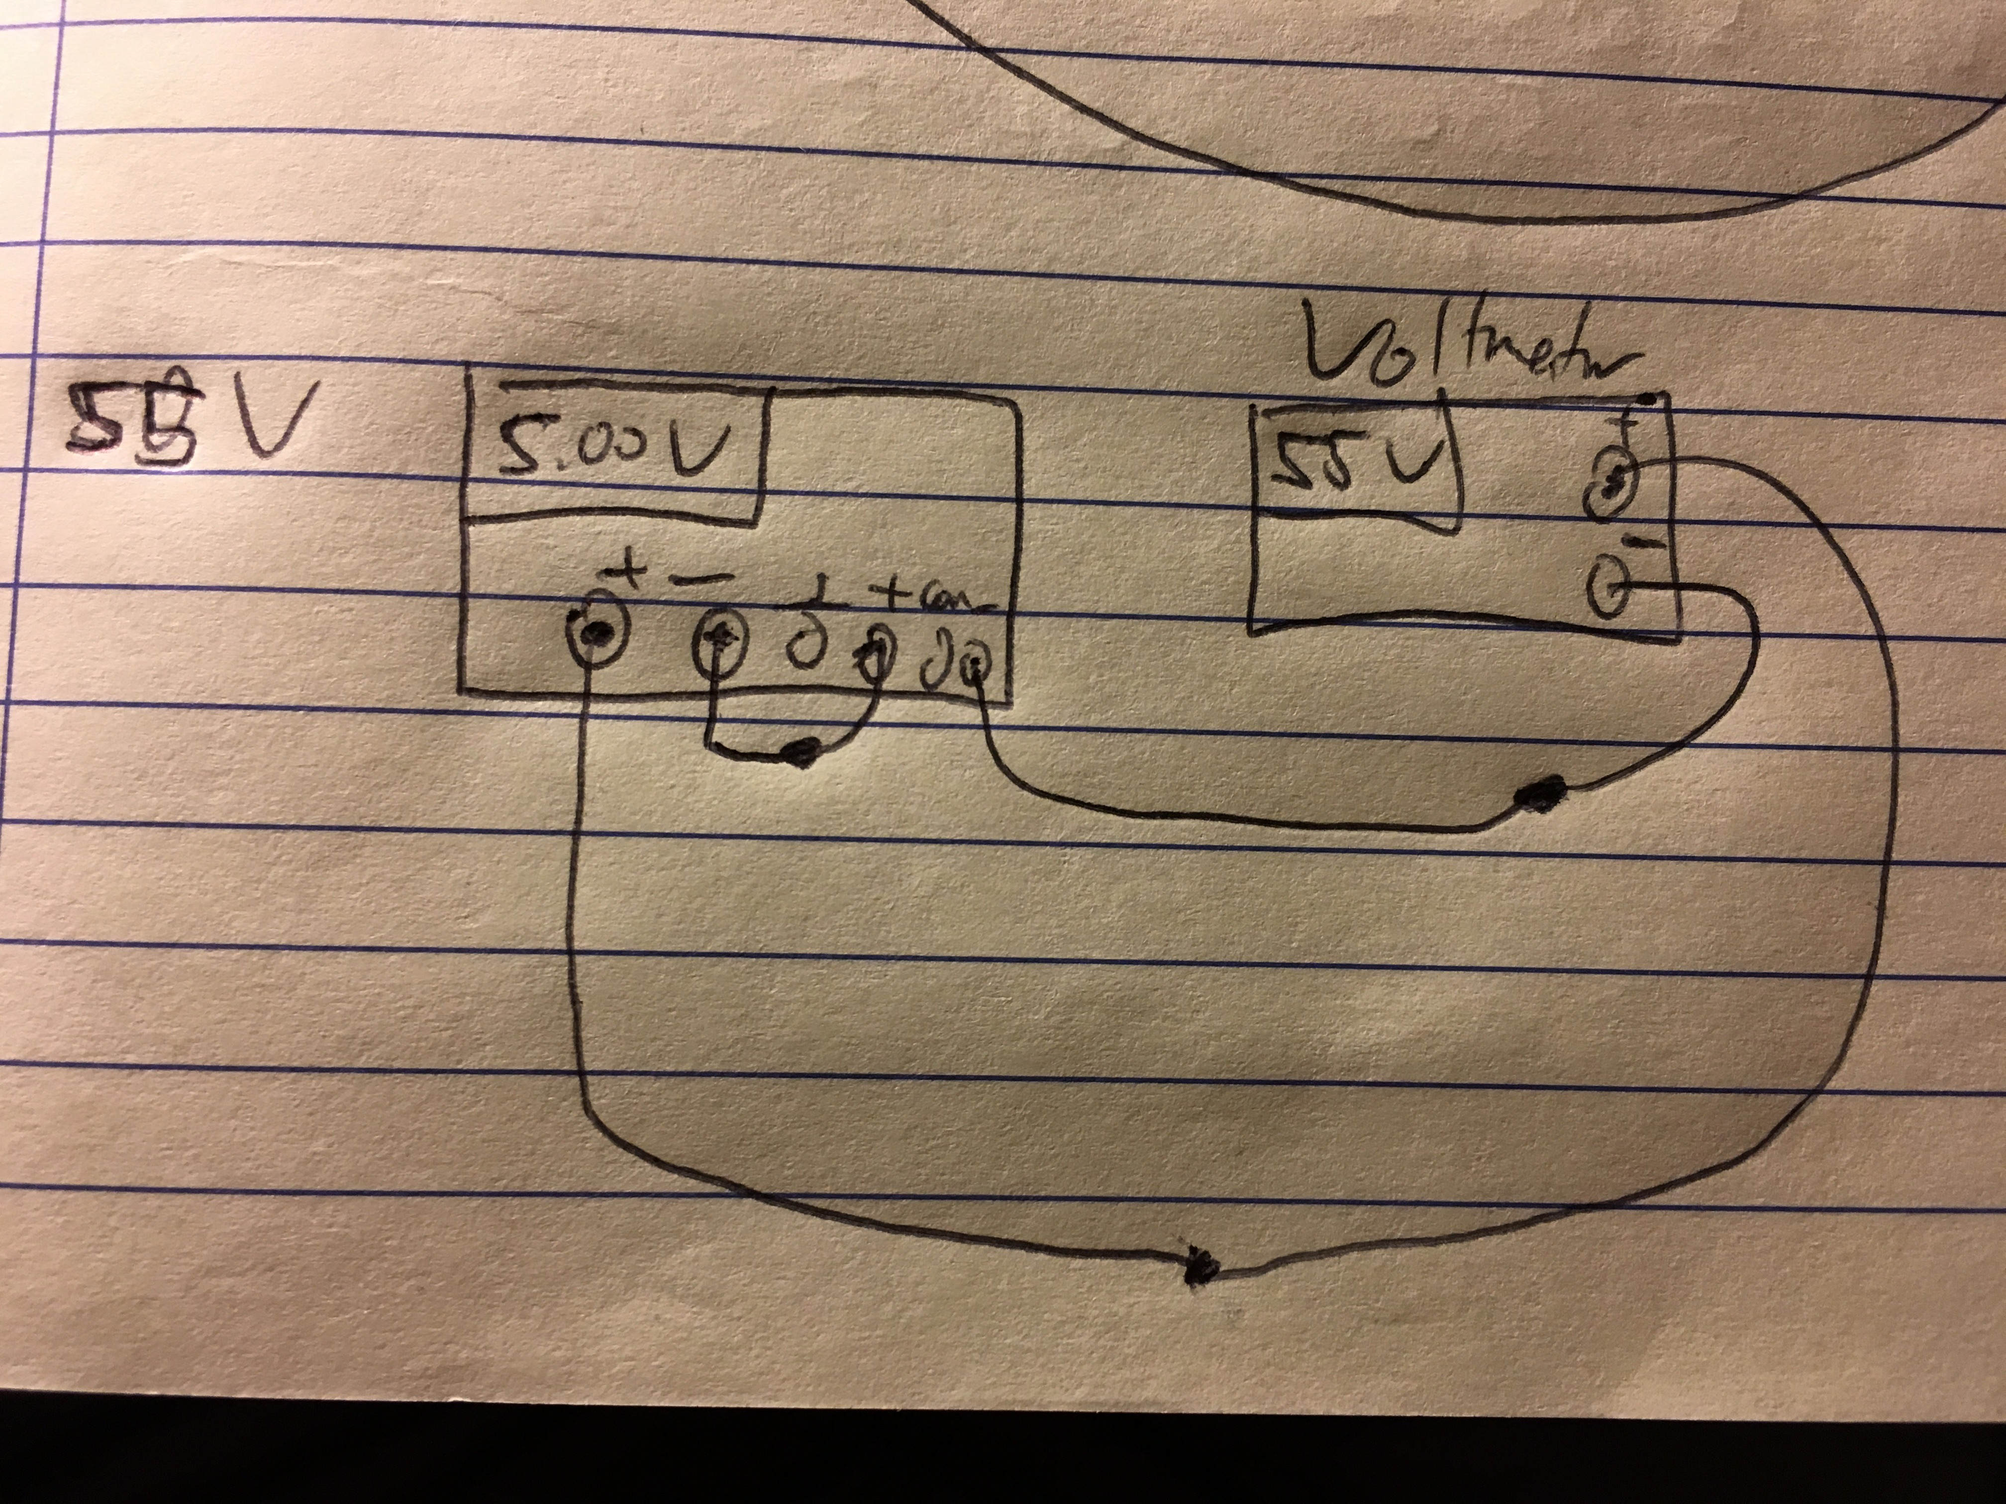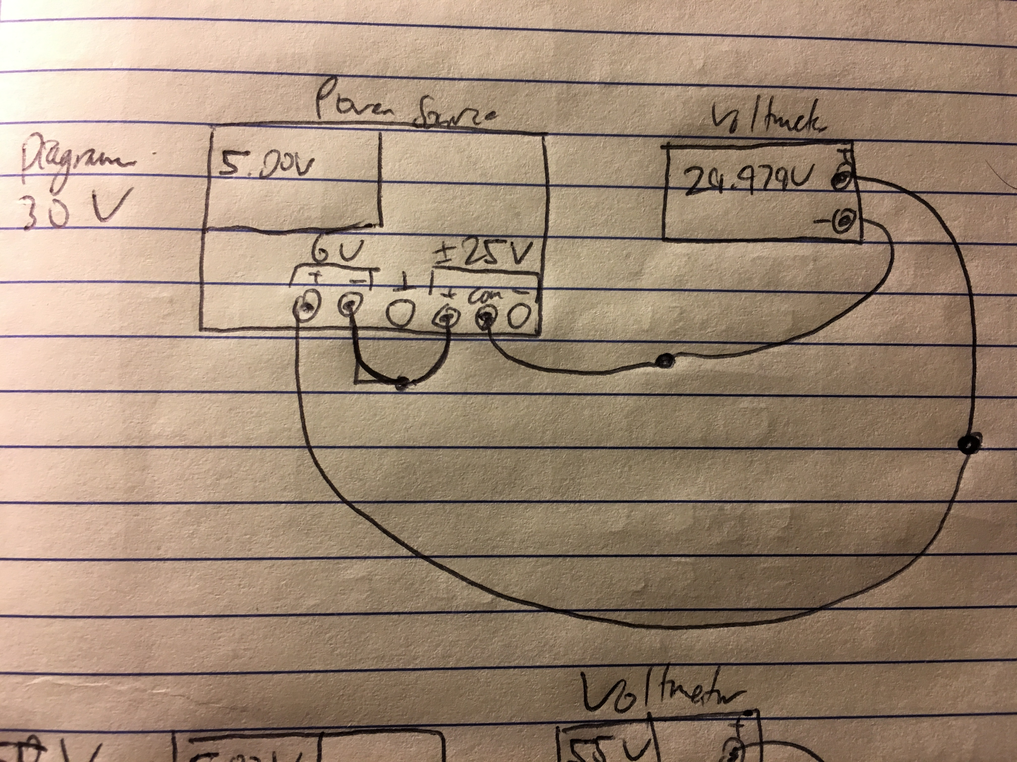

**Experiment #2**

Ohm’s Law describes how voltage and current are related with resistance. The higher the voltage, the lower the current needed to compensate. Likewise, the higher the current, the lower the voltage needed. When a resistor is connected across a power source like in this experiment, the voltage and current will automatically adjust based on the power source’s settings. In this experiment, the power source tries to output a constant voltage and will adjust the current as needed.

Measurements were made in ENG 249 Station 10 on Thursday, September 8, 2016 using

* HP E3631A Triple Output DC Power Supply (S/N: KR90917880)

Experiment Questions:

1. and 2. Voltage and current are shown before and after a 10Ω is connected.

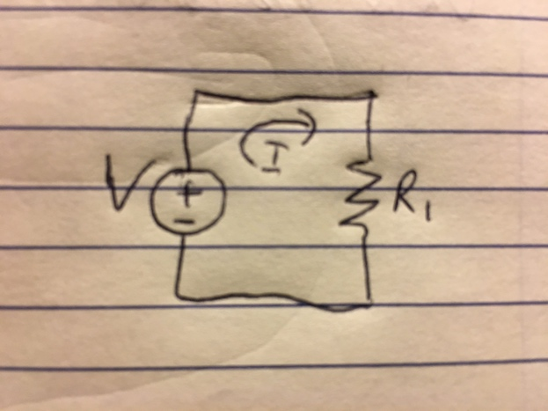

|  |  |  |  |  |
| --- | --- | --- | --- | --- |
|  | 10Ω | | 47Ω | |
| Voltage (Volts) | Current (Amps) | Voltage (Volts) | Current (Amps) |
| Before | 2 | 0.003 | 2 | 0.003 |
| After | 0.912 | 0.088 | 2 | 0.040 |

Ohm’s Law (V=IR) shows that as the resistance increases, the current must decrease to keep the voltage source outputting a constant voltage. Current and resistance are directly proportional.

**Experiment #3**

This experiment illustrates the meaning of power ratings on resistors. Resistors dissipate power. A voltage drop occurs over a resistor that reduces the voltage flowing in the circuit.



Measurements were made in ENG 249 Station 10 on Thursday, September 8, 2016 using

* 5W 10Ω Resistor - YAGED042
* HP E3631A Triple Output DC Power Supply (S/N: KR90917880)

Experiment questions:

Power Dissipation of a 10Ω resistor with 5V across it.

V = IR

I = V/R I = 5V/10Ω = **0.5A**

P = IV = 0.5A * 5V = **2.5W**

1. After applying 1.58V to a ¼W, 10Ω resistor, the resistor got noticeably hot.

2. After applying 5V to a ¼W, 10Ω resistor for 5 seconds, the resistor was extremely hot to the touch.

3. The step above was repeated with a 5W resistor as a 10W resistor was not available. The resistor was slightly warmer after 5 seconds.

The smaller a resistor, the lower its power rating. The larger 5W resistor can handle a higher voltage for longer before heating up too much.

**Experiment #4**

This experiment focuses on testing the prelab questions.

Measurements were made in ENG 249 Station 10 on Thursday, September 8, 2016 using

* HP E3631A Triple Output DC Power Supply (S/N: KR90917880)
* Digital Multi-Meter Agilent 34405A (S/N: TW47180090)

Experiment questions:

1.

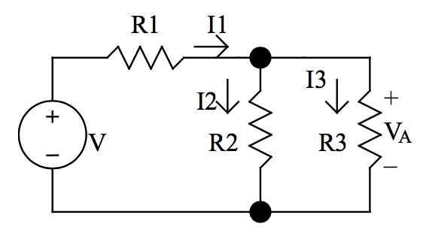

R1 = 1000Ω VA = 5.8852V

R2 = 2000Ω Req = 2.3939Ω

R3 = 5100Ω

I1 Calculations

VR1 = 4.1025V

I1 = VR1/R1

I1 = 4.1025V/1000Ω = 4.1025mA

I2 Calculations

VR2 = 5.8850V

I2 = 5.8850V/2000Ω = 2.9425mA

I3 Calculations

VR3 = 5.8845V

I3 = 5.8845V/5100Ω = 1.1538mA

2.

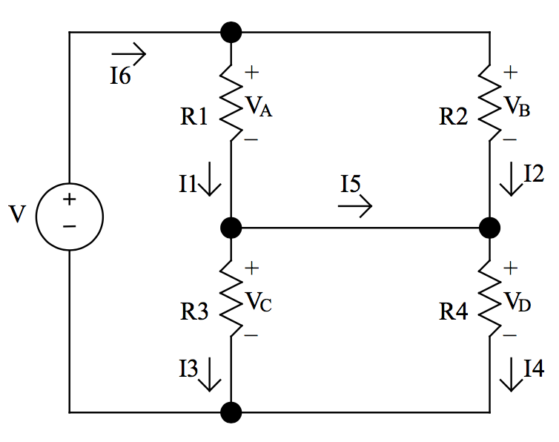

Req = 1.9494KΩ

VA = 6.9278V R1 = 2000Ω

VB = 6.9280V R2 = 2700Ω

VC = 5.0568V R3 = 1000Ω

VD = 5.0565V R4 = 5100Ω

I1 Calculations

V = IR I = VA/R1

I = 6.9278V/2000Ω = 3.4639mA

I2 Calculations

V = IR I = VB/R2

I = 6.9280V/2700Ω = 2.56593mA

I3 Calculations

V = IR I = VC/R3

I = 5.0568V/1000Ω = 5.0568mA

I4 Calculations

V = IR I = VD/R4

I = 5.0565V/5100Ω = 0.99147A

I5 Calculations

I1 = I5 + I3 I5 = I1 – I3

I5 = -1.5929mA

I6 Calculations

I6 = I3 + I4

I5 = 6.04827mA

All measured values compare well to the calculated values from the pre-lab. The laws used to calculate current indirectly include Ohm’s Law and Kirchoff’s Law.

**Experiment #5**

Current vs Voltage in a resistor follows a linear shape. In this experiment, we examine voltage vs current and resistance vs power as the voltage is increased in a light bulb.

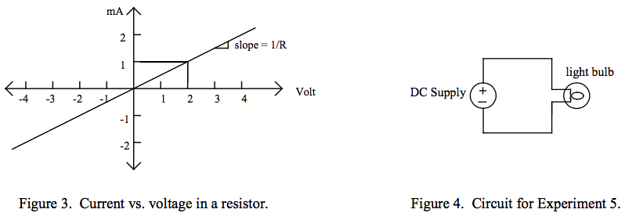

Experiment questions:

1. and 2.

|  |  |  |  |
| --- | --- | --- | --- |
| **Voltage (V)** | **Current (A)** | **Resistance [V/I] (Ω)** | **Power [V*I] (W)** |
| 0 | 0 | 0 | 0 |
| 0.2 | 0.022 | 9.090909091 | 0.0044 |
| 0.4 | 0.032 | 12.5 | 0.0128 |
| 0.6 | 0.037 | 16.21621622 | 0.0222 |
| 0.8 | 0.042 | 19.04761905 | 0.0336 |
| 1 | 0.047 | 21.27659574 | 0.047 |
| 2 | 0.068 | 29.41176471 | 0.136 |
| 3 | 0.085 | 35.29411765 | 0.255 |
| 4 | 0.101 | 39.6039604 | 0.404 |
| 5 | 0.115 | 43.47826087 | 0.575 |
| 6 | 0.128 | 46.875 | 0.768 |
| 7 | 0.14 | 50 | 0.98 |
| 8 | 0.151 | 52.98013245 | 1.208 |
| 9 | 0.163 | 55.21472393 | 1.467 |
| 10 | 0.173 | 57.80346821 | 1.73 |
| 11 | 0.183 | 60.10928962 | 2.013 |
| 12 | 0.192 | 62.5 | 2.304 |

3.

Note that the resistance of the light bulb is lower at lower voltages. This is due to the change of temperature of the filament in the light bulb.

**Experiment #6**

In this experiment, we examined the current versus voltage relationship of an LED.

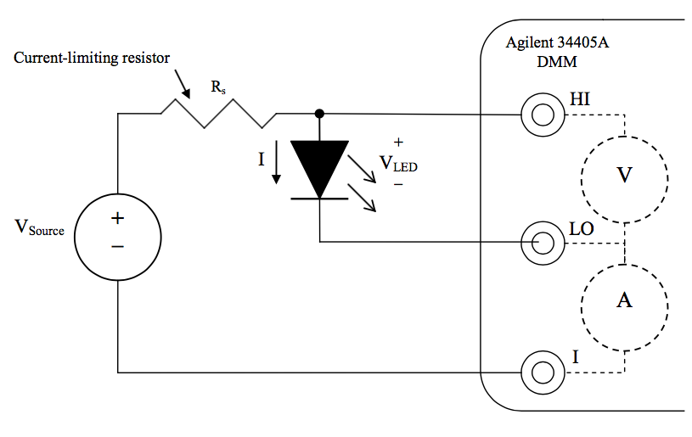

3.

|  |  |  |  |  |
| --- | --- | --- | --- | --- |
| Power Supply HP E3631A | | Digital Multi-Meter 34405A | | LED Brightness |
| Source Voltage (V) | Source Current (A) | Diode Voltage (V) | Measured Current (mA) | (no light, bright, etc.) |
| 0.5 | 0.000 | 0.50529 | 0.0 | No light |
| 1.0 | 0.000 | 1.00513 | 0.0 | No light |
| 1.5 | 0.000 | 1.4865 | -0.0191 | Little light |
| 2.0 | 0.000 | 1.6443 | -0.7421 | Little light |
| 2.5 | 0.001 | 1.6934 | -1.6933 | Noticeable |
| 3.0 | 0.002 | 1.7267 | -2.6774 | Noticeable |
| 4.0 | 0.004 | 1.7749 | -4.6857 | Bright |
| 5.0 | 0.006 | 1.8125 | -6.7144 | Bright |
| 6.0 | 0.008 | 1.8455 | -8.7620 | Very bright |
| 7.0 | 0.010 | 1.8748 | -11.014 | Very bright |
| 8.0 | 0.012 | 1.9035 | -13.124 | Very bright |
| 9.0 | 0.014 | 1.9291 | -15.227 | Extremely bright |
| 10.0 | 0.016 | 1.9546 | -17.352 | Extremely bright |

4. Polarity Reversed

|  |  |  |  |  |
| --- | --- | --- | --- | --- |
| Power Supply HP E3631A | | Digital Multi-Meter 34405A | | LED Brightness |
| Source Voltage (V) | Source Current (A) | Diode Voltage (V) | Measured Current (mA) | (no light, bright, etc.) |
| 0.5 | 0.000 | 0.50540 | 0.0000 | No light |
| 1.0 | 0.000 | 1.00520 | 0.0000 | No light |
| 1.5 | 0.000 | 1.4956 | -0.0001 | No light |
| 2.0 | 0.000 | 1.9962 | -0.0002 | No light |
| 2.5 | 0.000 | 2.4966 | -0.0003 | No light |
| 3.0 | 0.000 | 2.9961 | -0.0003 | No light |
| 4.0 | 0.000 | 3.9964 | -0.0004 | No light |
| 5.0 | 0.000 | 4.9956 | -0.0005 | No light |
| 6.0 | 0.000 | 5.9959 | -0.0006 | No light |
| 7.0 | 0.000 | 6.9979 | -0.0007 | No light |
| 8.0 | 0.000 | 7.9971 | -0.0008 | No light |
| 9.0 | 0.000 | 8.9977 | -0.0009 | No light |
| 10.0 | 0.000 | 9.9971 | -0.0009 | No light |

**Experiment #7**

When voltage is applied across a diode in such a way that the diode allows current, the diode is said to be forward-biased. When voltage is applied across a diode in such a way that the diode prohibits current, the diode is said to be reverse-biased. In this experiment, we examine the reverse bias behavior of a Zener diode.

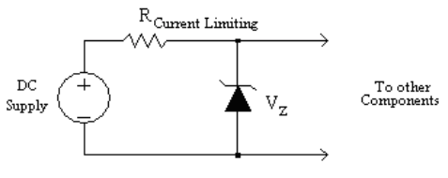

|  |  |  |  |
| --- | --- | --- | --- |
| **Voltage (V)** | **Current (A)** | **Voltage (V)2** | **Calculate Current [I*(qV/0.03)] (A)** |
| 0.500 | 0.000 | 0.50518 | 0.00000 |
| 1.000 | 0.000 | 0.70854 | 0.00000 |
| 1.500 | 0.001 | 0.73392 | 0.00000 |
| 2.000 | 0.002 | 0.74694 | 0.00000 |
| 2.500 | 0.003 | 0.75580 | 0.00000 |
| 3.000 | 0.004 | 0.76263 | 0.00000 |
| 4.000 | 0.005 | 0.77250 | 0.00000 |
| 5.000 | 0.008 | 0.78210 | 0.00000 |
| 6.000 | 0.010 | 0.78628 | 0.00000 |
| 7.000 | 0.012 | 0.79132 | 0.00000 |
| 8.000 | 0.015 | 0.79530 | 0.00000 |
| 9.000 | 0.017 | 0.79940 | 0.00000 |
| 10.000 | 0.019 | 0.80253 | 0.00000 |